**Steps:**

1. Setup a docker server OR use the docker lab

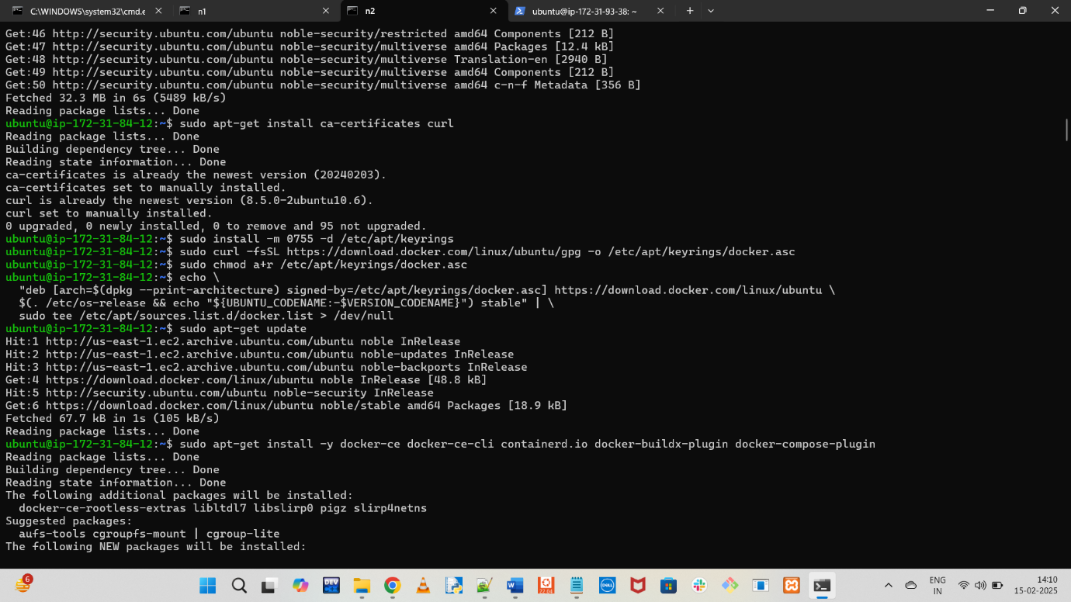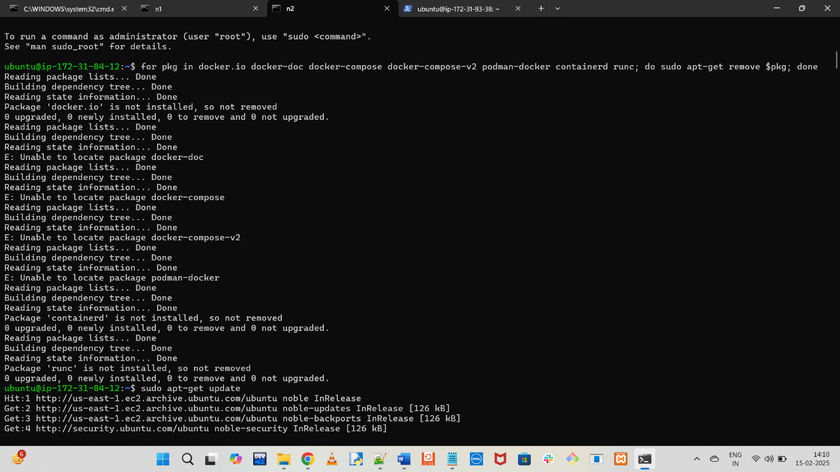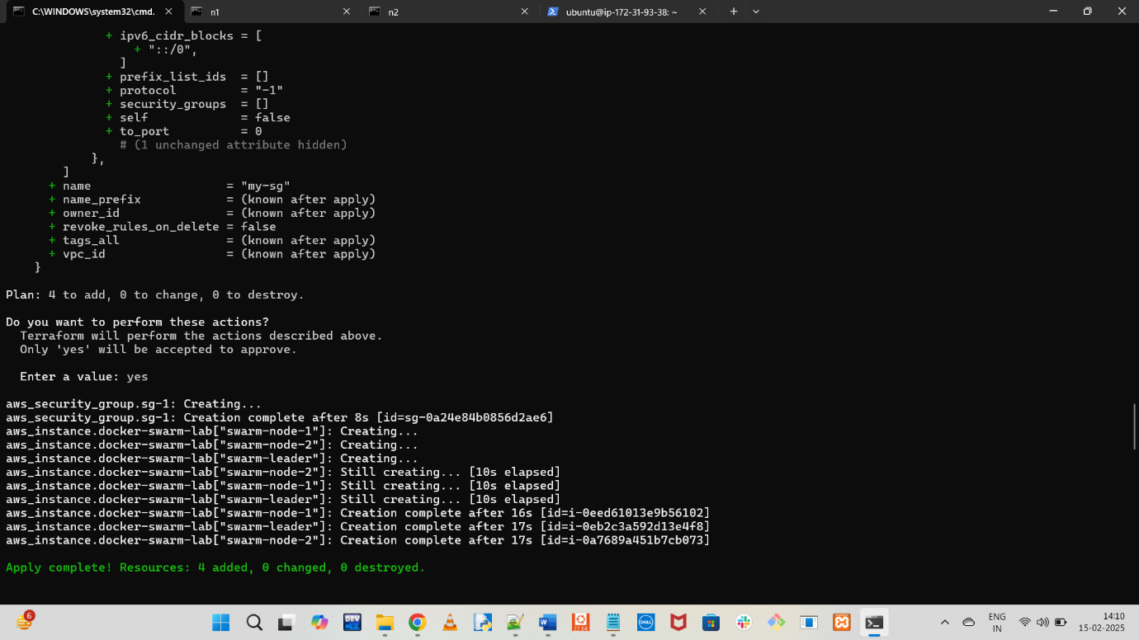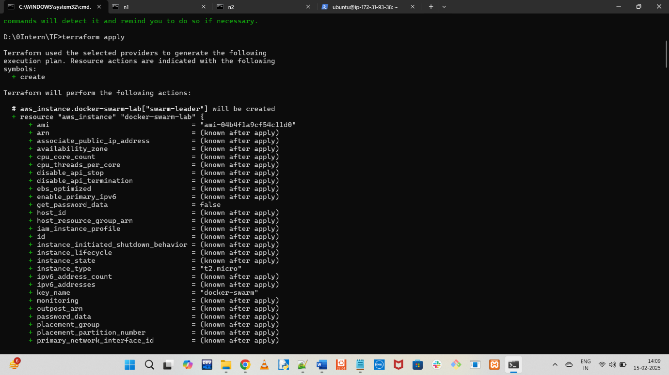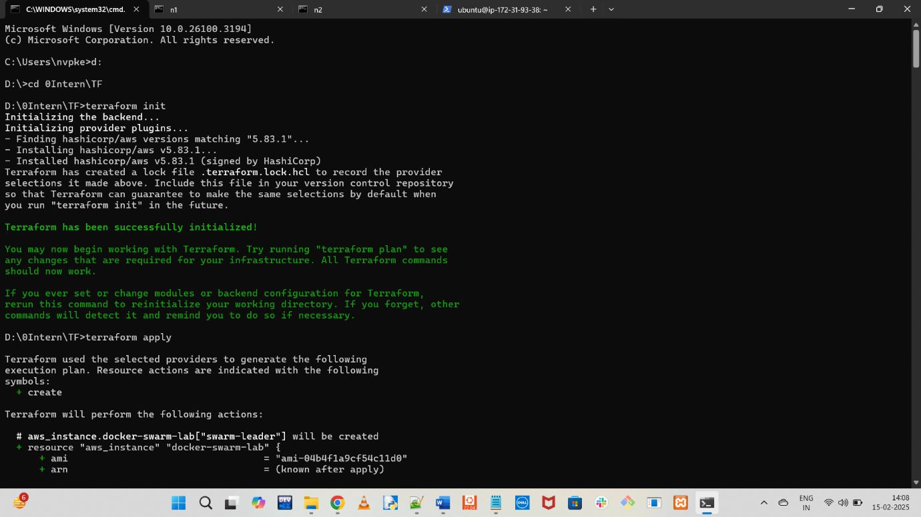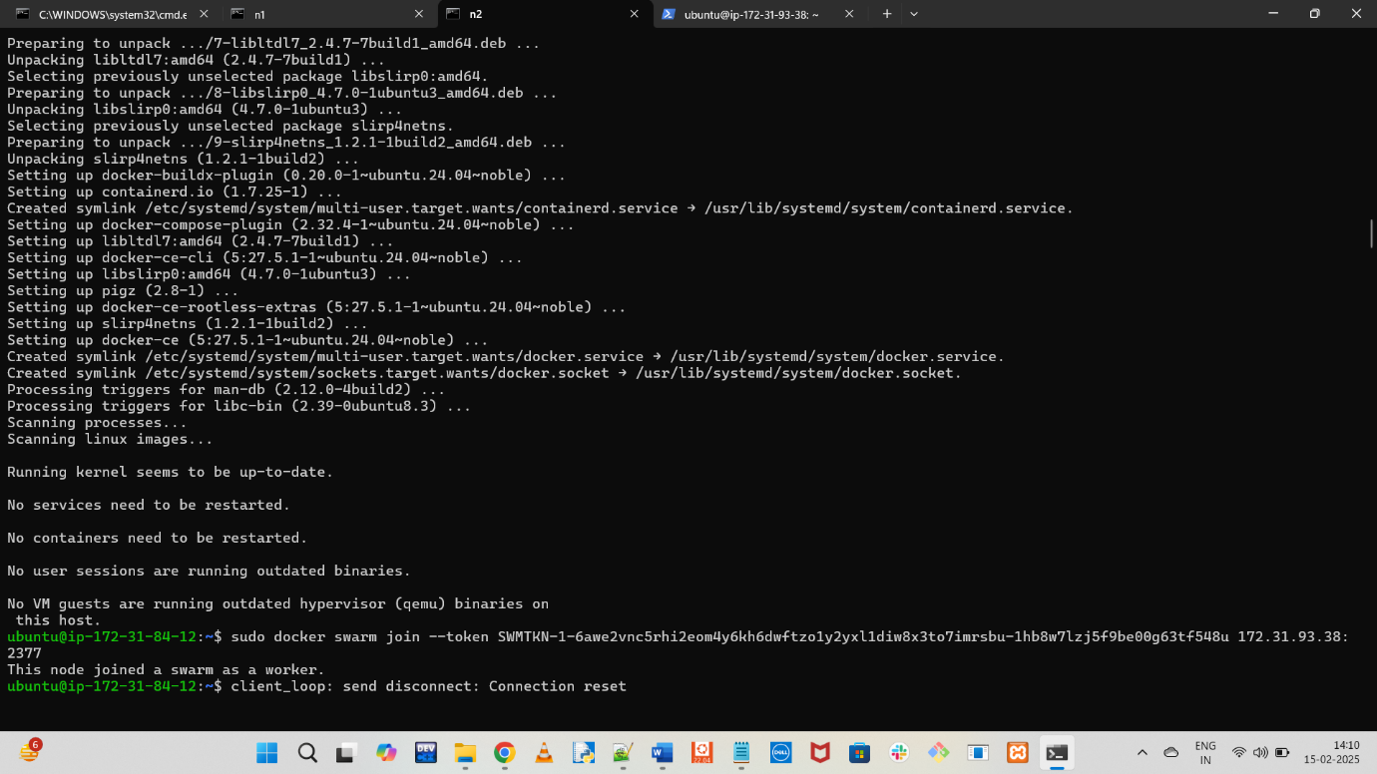

1. Clone the repo: <https://github.com/GithubWorkstation/docker-compose-lab-01.git>

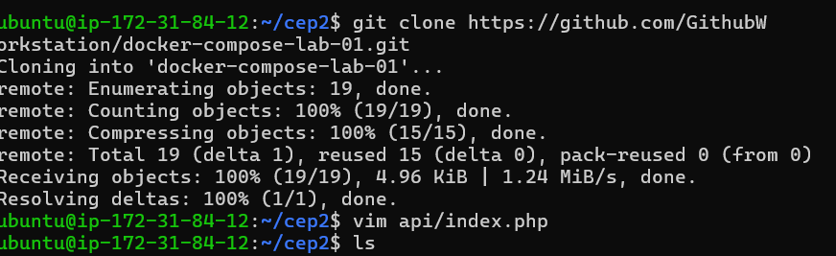

1. cd into the code dir:
   1. cd docker-compose-lab-01



1. edit backend api to add your server ip address in below line:
   1. vim api/index.php

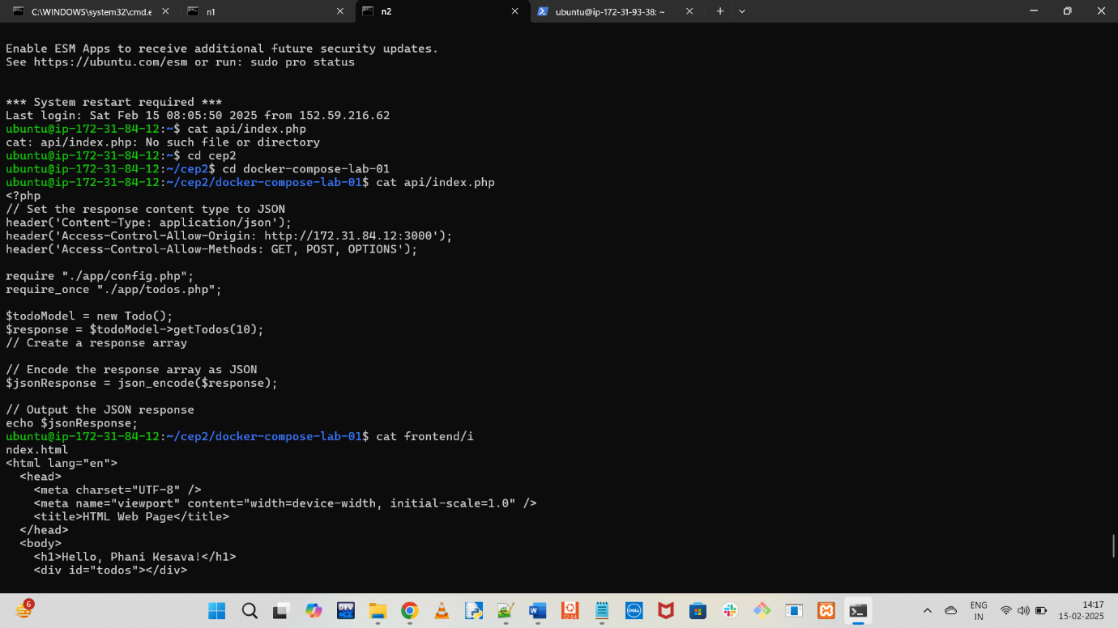

header('Access-Control-Allow-Origin: http://172.31.84.12:3000');

1. edit frontend to add serverIP
   1. vim frontend/index.html

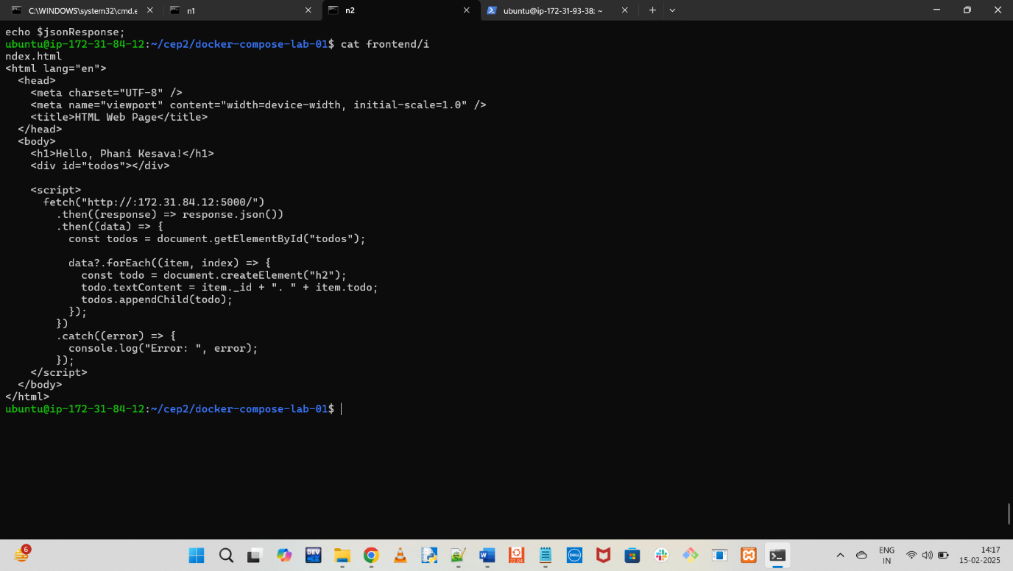

fetch("http://172.31.84.12:5000/")

1. bring all the services up
   1. docker compose up -d
2. check out all the services in the browser
   1. <http://3.82.187.145:5000/>
   2. <http://3.82.187.145:3000/>
   3. [*http://3.82.187.145:8080/*](http://3.82.187.145:8080/)

